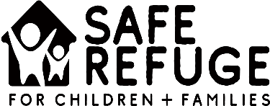

SRCF Ministry Lead/Family Coach Certification Check List

Thank you for your interest in becoming a Ministry Lead/Family Coach for Safe Refuge for Children + Families (SRCF). Below is a checklist to help you keep track of everything you need to do to be screened and approved. Please note that completion of these items does not guarantee certification as a ministry lead/family coach. In addition to the required documentation, we also recommend that you complete basic first aid and CPR training, TB Testing, water safety (if applicable) an emergency disaster plan, a digital photo of your family and shot records for any pets that you may have.

Please submit and upload all items online or email to admin@saferefugecf.org

Please retain this sheet for your records

- SRCF Application For Ministry Lead/Family Coach
- Sterling Volunteers Background Check – an invitation will be sent from Sterling Volunteers. Approximately $50, paid by applicant.

- Copy of Driver’s License

- Printout of Driving Record from www.dmv.ca.gov

- Copies of Vehicle Insurance

- Statement of Faith

- Confidentiality Agreement

- Safe Refuge for Children + Families Live Training Complete

- Pastoral Reference (One Per Family)

- Friend/Colleague Reference #1 (One Per Family)

- Friend/Colleague Reference #2 (One Per Family)

Please contact the Safe Refuge for Children + Families office with any questions at admin@saferefugecf.org or call the office at 925.566.8050.

